**Khulna University of Engineering and Technology**

**Department of Computer Science & Engineering**



**“Online Common Room”**

Internet Programming Laboratory

Course No – CSE 2200

|  |
| --- |
| **Developed by:**  Rashik Hasnat - 1107004 |
| **Supervised by:**  1.Dr. Md. Aminul Haque Akhand  Professor, CSE, KUET  2.G. M. Mashrur-E-Elahi  Assistant Professor, CSE, KUET |

|  |
| --- |
|  |

**Acknowledgement**

First and foremost, praises and thanks to Allah, the Almighty, for His showers of blessings throughout the entire time during the development of this project.

I want to thank my supervisor Dr. Md. Aminul Haque Akhand sir and G. M. Mashrur-E-Elahi sir for their great support during this project. It would have been impossible to do this project without their advices. They showed me the proper direction during the whole time and it helped me a lot in completing this project successfully.

I want to thank our seniors too for their useful advices during the project.

Any kind of suggestions or criticisms will be highly appreciated.

**Overviews**

* Introduction………………………………………………………………………………………………………………………03
* Objective…………………………………………………………………………………………………………………………..03
* Design and Functionality……………………………………………………………………………………………………03
* Table of Contents………………………………………………………………………………………………………………03
* Graphical Diagram of User…………………………………………………………………………………………………03
* Graphical Diagram of Admin…………..…………………………………………………………………………………04
* Program/Web Design………………………………………………………………………………………………………..05
* Coding Background……………………………………………………………………………………………………………08
* Future Plan………..………………………………………………………………………………………………………………09
* Conclusion…………………………………………………………………………………………………………………………09
* References…………………………………………………………………………………………………………………………09

**Introduction:**

In today’s life, there are immense importance of web site development. As we are entering into an era of Digital Bangladesh, we want everything to be online. That’s where the idea of online common room comes from. Its an online platform for both the students and teacher for making it easy to communicate, share and learn!!

**Objectives:**

* I have built a website which works pretty much as a common room to the students and teacher. Here Class Representative (CR) or teacher can upload class lectures, update CT Schedules. Teachers can publish CT Results. The general students can easily be up to date with there class lectures and upcoming tests and their results.
* So the website will both help the teachers and students. Also unwanted members will be prohibited as only registered users can log into the website.

**Design and Functionality:**

Online Common Room Website is designed both for the feasibility of the Teachers and Students. The website has two main interfaces, one for teachers and students other one for the admin.

**Table of Contents:**

1. Graphical Diagram of the User(Teacher and Students)
2. Graphical Diagram of the Admin

**Graphical Diagram of User: (Teacher and Student)**

From a user perspective, Online Common Room has the basic structure like any website for the user feasibility. This is illustrated by the following block diagram:

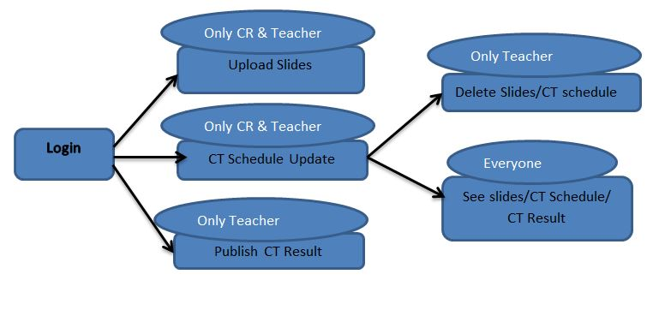

**Fig 1: Block Diagram for teacher and students**

The User Page consists of the following items:

***Upload Slides****:* Here only the teacher and CR can upload class lectures as slides.

***Update CT Schedule****:* Here only the teacher and CR can update CT Schedule and routine for upcoming days.

***Publish CT Result****:* Only teacher can generate marks sheet and publish it.

***Delete CT Schedule/ Slides****:* Here only the teacher can delete a slide or ct schedule.

***Download Slides****:* Only the Teacher can download all files. Students are allowed to download files for their year only. So they cannot download files of other year.

**Graphical Diagram of Admin:**

From an admin perspective, Online Common Room has the basic structure like any website for the admin feasibility. This is illustrated by the following block diagram:

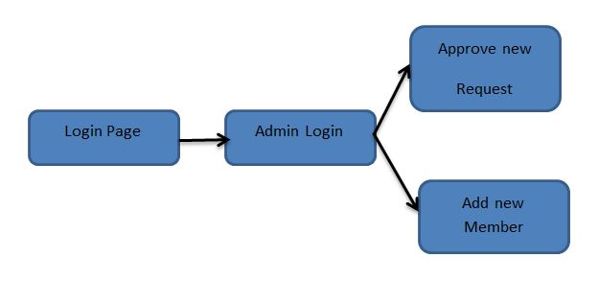

**Fig 2:Block Diagram Admin**

The Admin Page consists of the following items which has different functionality according to its uses.

***Accept Pending Request****:* Here the admin can accept the join request sent to the group.

***Add New User****:* Here the admin can add new user to the Online Common Room.

**Program/Web Design:**

* ***Login page:*** This is the first page of Online Common Room. Here you can login with your username/roll//mail ID and your password.

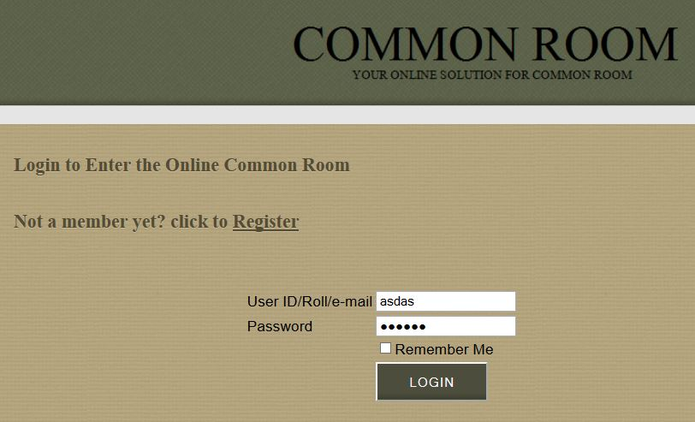

Fig 3: login Page

* ***Register***: Here new users without any account can apply to register. After his submission he/she can only access the website after the approval from the admin.

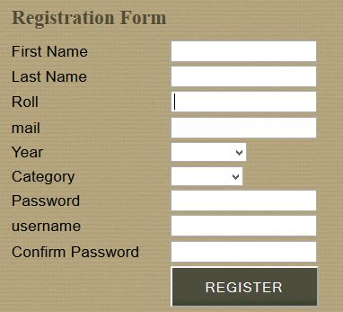

Fig 4: Registration form

* ***Index:*** This is the first page that you enter after valid login. Here you can have an idea about the purpose of this website.

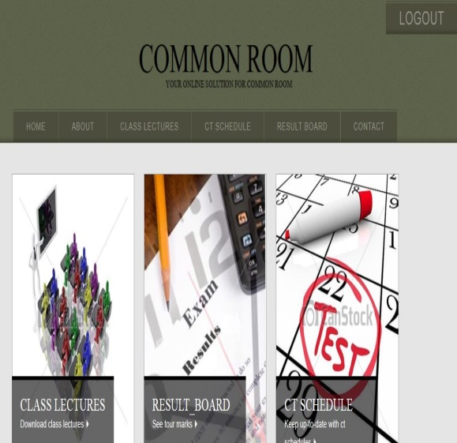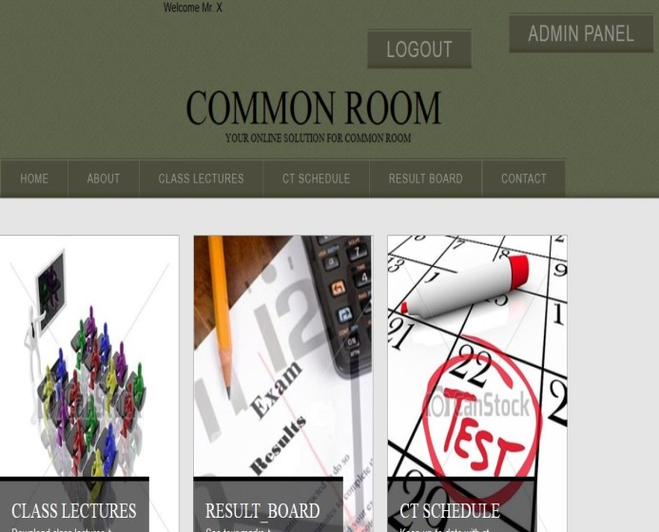

Fig 5(a): index for teacher & students Fig 5(b): index for admin

* ***Admin Panel:*** Only the admin of the website can access to this page. Here he/she can approve/reject joining requests and add more members.

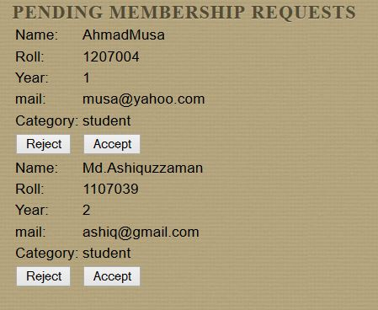

***Fig 6:*** Admin Approval

* ***About:*** This page is aimed to inform the users about the department of Computer Science of KUET. A brief history of this department and its facilities are stated here.

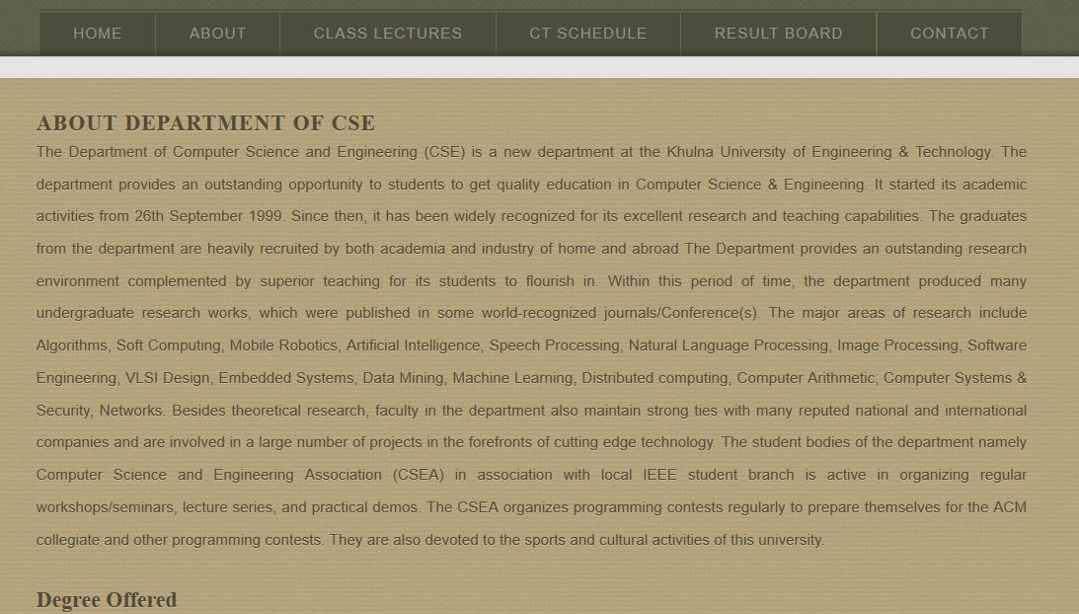

***Fig 7:*** About Me

* ***Class Lecture:***Here Teachers and class Representatives can upload class lectures as slides. General students can easily download uploaded slides of their year by clicking the download link. The permission to delete a slide is preserved only for the teachers.

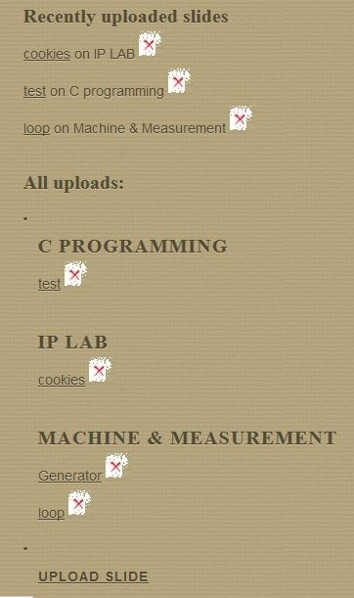

***Fig 8:*** Class Lectures

* ***CT Schedule:*** Here Teachers and admin can update CT schedule with CT syllabus, date and course teacher. Students can see their next class tests according to date. The permission to delete a class test schedule is preserved only for the teachers.

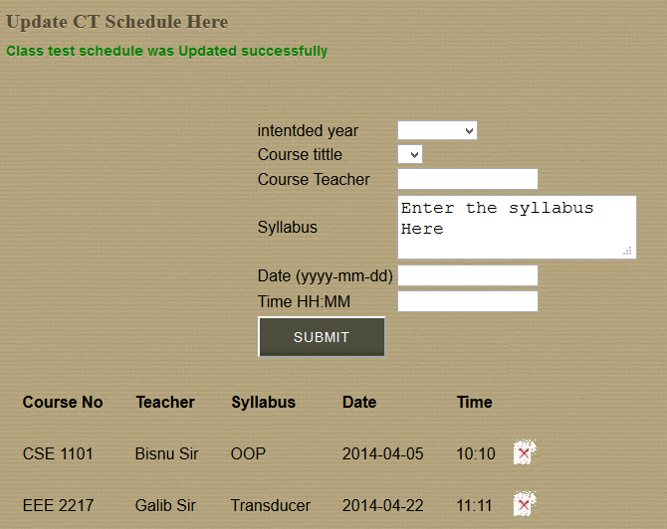

***Fig 9:*** ct schedule

* ***Result Board:*** Here Students can see their class test results. Here the course name and CT is given in this page. If a student/teacher clicks on it he/she can see the course result. Teachers put the marks of the students in an auto generated marks sheet and publish it. A techer can have this auto generated marks sheet only after selecting the intended year and course.

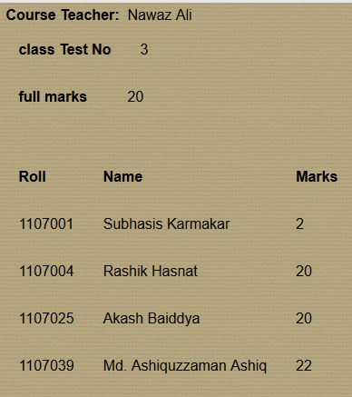 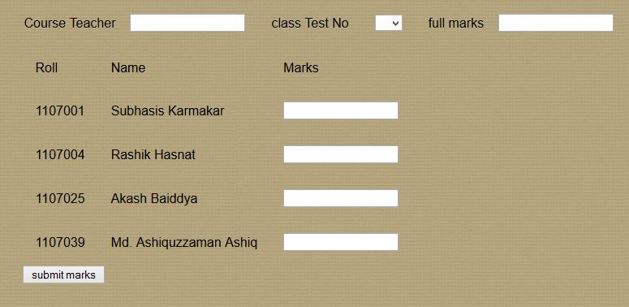

Fig 10(a): Published Result fig 10(b):Auto Generated sheet

* ***Contact:*** This page gives the user the contact information about the developers and the Department of CSE.

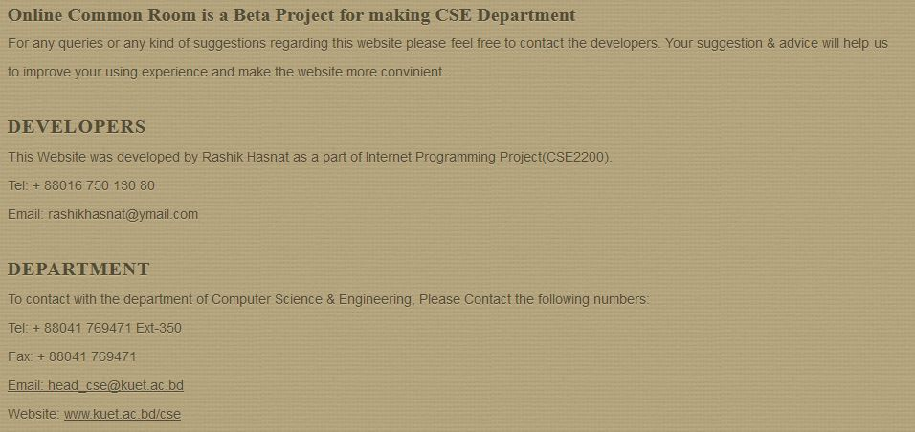

Fig 11: Contacts

**Coding Background:** As I’ve mentioned earlier, this project was mainly done in php language. I also used html and css for page decoration. Javascript and ajax were used for smooth user experience. The database of this project was managed by mysql DBMS. No external plugin was used in the whole website. I am really thankful to [www.freetemplate.com](http://www.freetemplate.com) for the open source html template they provided, because I edited and modified their template and used it in this project.

A total of 29 php files and one javascript file was used for the whole project.

**Future Plan:**

* This website can be upgraded by adding comments of the user to each of the files. Student can also chat with Teacher to solve anything from the website.
* A photo Gallery can be added.
* It can be upgraded in such a generalized way so that every department can use this site as their online common room.
* More features can be added for the admin.

**Conclusion:**

It had been a challenging task to develop a website on PHP. I also tried to implement some javascript and ajax into this to make it easier for the users to use it. This project made me learn many new and amazing facts about php, html, css, ajax, javascript and mysql. As I was focused to my objectives and as a result of fact I managed to complete the project.

**References:**

1. [**http://www.w3schools.com/**](http://www.w3schools.com/)
2. [**http://stackoverflow.com/**](http://stackoverflow.com/)
3. [**https://api.jquery.com/category/ajax/**](https://api.jquery.com/category/ajax/)
4. [**www.Lynda.com**](http://www.Lynda.com)